Activity Book

Innovation & Design Thinking Using Atal Idea Lab / Tinkering Lab / Makerspace
(Activity-Based Learning)



Academic Year: 2025-26 Semester: 1

Student Name:R.Nalini Roll No:ISI38

Branch: Information Science and Engineering USN:

Team Name and Strength: Mentor / Faculty Member Name:
Table of Contents

Week | Module Title | Activity Title | Page No. | Sign
1–3 | Orientation and Team Formation | Communication & Team Activities
4–5 | Empathy and Field Exploration | Stakeholder Interviews/Interaction
6–8 | Problem Definition | “How Might We…”  Framing
9–11 | Ideation Sprint | Brainstorming & Idea Selection
12–14 | Prototyping | Prototype Development
15–16 | Final Demo & Social Pitch | Innovation Pitch

Sl.  No. | CIE  Component/Week | Max Marks | Description | CIE Marks Obtained | Sign
1 | Orientation Activities & Communication Skills | 5 | Participation in Week 1–3 orientation, communication and teamwork skill-building exercises.
2 | Empathy & Field Exploration Documentation | 10 | Quality and completeness of field visit reflections, stakeholder interviews, and activity book.
3 | Problem Definition and Framing | 10 | Clarity of challenge statements, use of “How Might We”, Affinity Mapping, Problem Trees.
4 | Ideation & Mind Mapping | 10 | Participation in brainstorming, mind mapping, idea filtering sessions.
5 | Prototype Development & Iteration | 10 | Quality and creativity of prototype/model, user testing, feedback collection, iterations.
6 | Teamwork, Journal, and Engagement | 5 | Peer and mentor evaluation of participation, teamwork, journal updates.
7 | Total CIE marks | 50 | Final CIE marks to be considered

- Write about Innovation and Design Thinking
Innovation means thinking in a new way and creative way to solve problems or improve existing ideas. It is about doing things differently instead of always following the same methods. Innovation can be seen when we create new products, improve technology, or find easier ways to complete work.
For students, innovation helps in developing creative thinking and problem-solving skills. It encourages us to explore new ideas, learn from mistakes, and apply knowledge in a practical way. Innovation plays an important role in education and helps students prepare for future challenges.

Design Thinking is a method of solving problems by thinking from the user’s point of view. It focuses on understanding the needs of people and finding creative and practical solutions. Instead of directly jumping to an answer, we first try to understand the problem clearly.
Design thinking involves steps like understanding the problem, thinking of different ideas, making simple models, and testing them. This approach helps students to think creatively, work in teams, and develop better solutions for real-life problems.

- Brief of Innovation and Desing Thinking Empathize –
Empathize in innovation means carefully understanding the users and their problems before creating any solution. It involves listening to people, observing their situations, and trying to understand their feelings and needs.
By empathizing, innovators can identify real problems and design solutions that are more useful and meaningful. This step helps us and innovators create ideas that truly help people and improve
Emapthize in design thinking is the first step where we try to understand the users and their problems. It means observing people, listening to their experiences, and understanding their feelings and needs.
This step helps us clearly identify the real problem. By empathizing, better and more user-friendly solutions can be designed.

Define –Innovation is the process of developing new ideas or improving existing ideas to solve problems in a better and more effective way. It involves creative thinking and applying knowledge to make things useful and efficient.
Design thinking is a problem-solving approach that focuses on understanding the needs of people and finding creative solutions. It helps us think in a systematic way by first understanding the problem and then generating ideas to solve it.
Design thinking encourages creativity, teamwork, and practical thinking. It is useful for us to solve real-life problems in a simple and effective manner.

Ideate-Ideate is the stage of innovation where we generate many ideas to solve a problem. In this step, we think creatively and freely without judging the ideas. Brainstorming is commonly used during ideation to come up with new, unique, and practical solutions. The main aim of ideate is to explore different possibilities and choose the best idea for further development.
Ideate of design thinking where we generate different ideas to solve the identified problem. In this stage, we use creativity and imagination to think of many possible solutions without criticizing them. Techniques like brainstorming, mind mapping, and sketching are used to develop ideas. The goal of the ideate stage is to select the most effective and innovative idea to move forward.

Prototype-Prototype is the stage of innovation where a simple model or sample of an idea is created. It helps us to understand how the idea will work in real life. Prototypes can be in the form of drawings, models, or basic working versions. This stage allows us to test the idea, identify problems, and make improvements before final implementation.
Prototype of design thinking where we create a basic version of the selected idea. It helps in visualizing the solution and understanding how it will work in practice. Prototypes can be simple models, sketches, or mock-ups. This stage helps to identify errors, get feedback from users, and improve the solution before finalizing it.

Testing and validation-Testing and validation is the stage of innovation where the developed idea or product is checked to see if it works properly. In this stage, the prototype is tested under real or simulated conditions. Feedback is collected to identify mistakes and areas for improvement. Validation helps to ensure that the innovation meets user needs and solves the problem effectively before final use.
Testing and validation is the final stage of design thinking where the prototype is tested with users. In this stage, users interact with the solution and give feedback. This helps to find problems, understand user satisfaction, and make necessary improvements. Validation ensures that the solution effectively solves the problem and meets user needs.

Week 1–3: Orientation & Team Formation (additional sheets may be attached, if required)
  - Activity Title: Hardware Implementation and Initial Prototyping of IoT-Based Accident Detection System
  - Objective: The objective of this activity is to design and assemble the basic hardware prototype of the IoT-based accident detection system by interfacing the microcontroller with an accident detection sensor using a breadboard. This activity aims to understand the fundamental hardware connections, working principle of the sensor, and data acquisition by the microcontroller. It focuses on testing the sensor’s ability to detect sudden impact or vibration and ensuring proper power supply and signal flow. This initial hardware setup helps in validating the accident detection mechanism and provides a strong foundation for future enhancement of the system with additional modules such as GPS and wireless communication for emergency alert generation.

  - Tasks Done: Identified and collected the required hardware components such as the microcontroller, accident detection sensor, breadboard, jumper wires, and power supply.
  - Studied the pin configuration and working principle of the accident detection sensor.
  - Mounted the microcontroller on the breadboard and ensured proper placement for easy connections.
  - Connected the accident detection sensor to the microcontroller using jumper wires.
  - Verified power supply connections and ensured correct voltage levels to all components.
  - Checked the continuity and stability of all wiring connections to avoid loose contacts.
  - Observed and verified the sensor response during sudden vibration or impact conditions.

  - Skills Developed:
1.learned how to use ESP32 Microcontroller.
2.Gained knowledge of Sensors and GPS module.
3.Improved programming skills using Arduino.
4.Understood Hardware and software interfacing.
5.Developed problem solving ability.
6.Learned team work and communication.
7.Improved presentation and documentation skills
8.Gained awareness about road safety and social responsibility.

  - Output / Reflections:
1. The IOT based accident detection system was successfully designed and implemented.
2. The system is able to detect accidents automatically using sensor date.
3. An alert mechanism was demonstrated to indicate occurrence of an accident.
4. The project helped us understand real-time IOT system and safety applications.

  - Faculty Signature with remarks
Week 4–5: Empathy & Field Exploration
  - Field Visit Location: Gopalan college of engineering and management.
  - Date of Visit:
  - Stakeholders Met (Mention the names of Min10 Stake holders):

  - Interview Questions Asked:

  - Key Observations:

  - Photos / Sketches: (Paste or attach)
  - Challenges Noted:
- Hardware – Software synchronization issues between GPS module and microcontroller
- Power supply fluctuations affected for module performance.
- Sensors threshold tuning was required to avoid false accident detection
- Integration of multiple IOT components was time-consuming and complex.
- GPS module did not function as expected during project implementation.
- GPS data was not received by the microcontroller.

  - Faculty Feedback & Signature:
Week 6–8: Problem Definition
  - List of Problems Identified:
- Delay in getting help after road accidents
- Victims may be unconscious and unable to call for help.
- Lack of quick accident detection mechanism.
- Difficulty in identifying accident occurrence in real time.

  - Empathy Map / Problem Tree Analysis or Drawing:

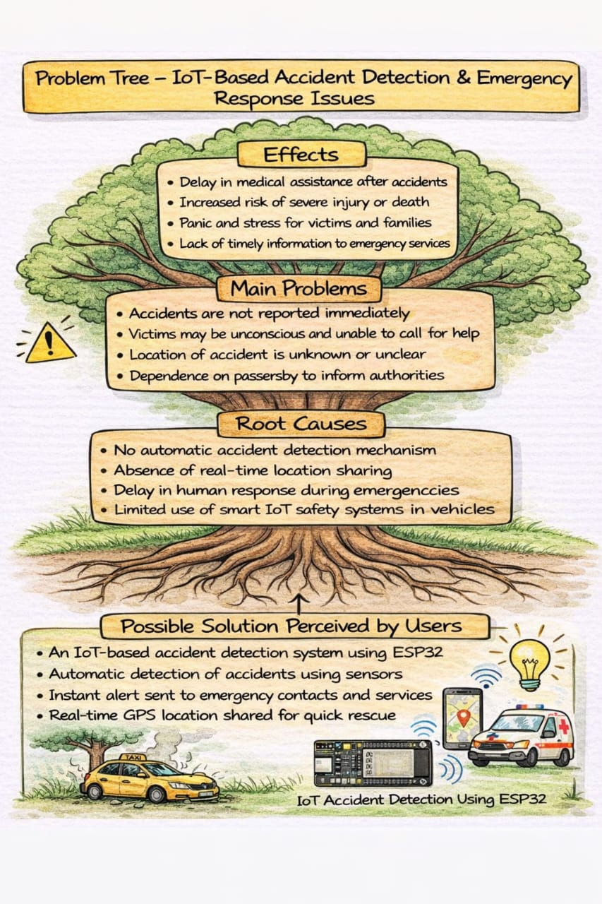

  - Defined Problem Statement:
“How might we design a low-cost system that automatically detects road accident and alerts concerned authorities to reduce emergency response time.

  - User Pain Points Identified w.r.t. Defined Problem Statement:
  - Time delay
  - Lack of communication
  - Dependence on manual help

  - Faculty Feedback & Signature:
Week 9–11: Ideation Sprint
  - Techniques/Platforms Used: Brainstorming Sessions/ Group Discussions/Mentoring/Mind Mapping
  - Ideas Generated (List 10 or more)
- Helmet-based alert system
- Mobile app-Based detection
- Camera-based alert system
- IOT accident detection using sensors
- GPS-based alert system
- Vehicle vibration detectors
- Wearable safety device
- Panic button system
- Smart speed limiter
10.Automatic emergency call system

  - Idea Selected for Prototyping:
IOT -based Accident detection system using MPU6050 and ESP32

  - Justification for Selection:
- Low cost
- Easy implementation
- Reliable sensor-based detection
- Scalable solution
- Useful even when GPS is not working
- Reduces human error
- Low power consumption
- Improves road safety
- User-friendly system
10.Real-time monitoring capability

  - Initial Design Sketch: Brief about Initial Design (Attach the sketch)

  - Faculty Feedback & Signature:
Week 12–14: Prototyping
  - Materials Used:
  - Prototype Description:
  - The prototype of the MPU6050-based Accident Detection System is designed to demonstrate the detection of sudden impacts using acceleration data. The system consists of an ESP32 microcontroller interfaced with an MPU6050 accelerometer and gyroscope sensor. The MPU6050 continuously measures acceleration along the X, Y, and Z axes.
  - The ESP32 processes the raw acceleration values and converts them into G-force. Under normal conditions, the G-force remains close to 1g due to gravity. When a sudden impact or sharp movement occurs, the G-force exceeds a predefined threshold, and the system identifies it as an accident.
  - Upon detecting an accident, the ESP32 triggers an alert by displaying a warning message on the Serial Monitor and optionally activating an LED or buzzer. The prototype is assembled on a breadboard using jumper wires, allowing easy testing and modification of the system.
  - This prototype effectively validates the core concept of accident detection using sensor data and serves as a foundation for future enhancements such as GPS location tracking, wireless alerts, and battery-powered operation.

  - Photos of Model (attach separately):

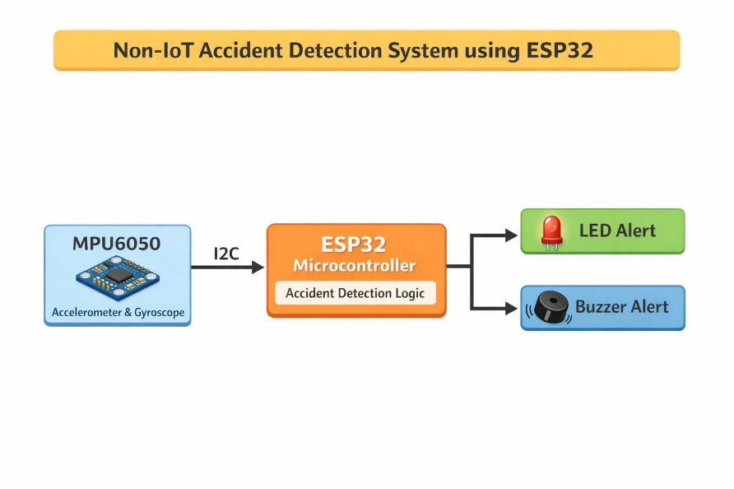

  - User Testing Report:
- Tested by shaking and impact simulation
- Verified G-Force readings
- Accident detection triggered correctly
- MPU6050 sensor readings were observed during testing
- Alert message was generated after accident detection
- The response time of the system was quick
- The system worked properly
- No false accident detection system occurred during normal movement

  - Feedback Received (List out the important/crucial points):

  - Revisions Made:
- Threshold adjustment
- Code optimization

  - Faculty Feedback & Signature:

Week 15–16: Final Demo & Pitch
  - Project/Idea Title: IOT-Based Accident System Using ESP32
  - Team Members:
- Sai Srikanth
- Jahnavi
- Goutham . R
- R . Nalini

  - Targeted Problem: Delayed emergency response after road accidents

  - Final Report of the Project: Attach Separately
  - Pitch Summary: Poster/PPT: Attach Separately

  - Jury Comments:

  - Marks (out of 50):

  - Faculty Signature:

Final Reflection & Self-Assessment (Student shall answer the following questions prior to final viva-voce or presentation)
  - What did I learn from this course?

  - Skills I gained:

  - Challenges I faced and overcame:

  - What would I do differently next time?

  - Faculty Suggestions:

Innovation & Design Thinking Lab |  | Semester | 1
Course Code: | 1BIDTL158 | CIE Marks | 50
Teaching Hours/Week (L:T:P: S) | 0:0:2 | SEE Marks | 50
Total Hours of Pedagogy | 2 | Total Marks | 100
Credits | 1 | Exam Hours
Examination type (SEE) | Practical/Presentation/Seminar
Course Outcome (Course Skill Set) -
At the end of the course, the student will be able to:
- Empathize with community problems and define meaningful challenges.
- Apply design thinking principles and multidisciplinary skills to develop user-centric solutions.
- Build and test basic prototypes using tools available in the Atal Idea/Tinkering Lab or Makers Space.
- Pitch socially relevant ideas with scalable models.
- Collaborate effectively in diverse teams.
Week 1, 2 & 3: Orientation and Team Formation
Week -1&2: Introduction to Social Entrepreneurship, Innovation and Design Thinking
Group discussion on What is Innovation vs Invention. Why Design Thinking is important. Brief about 5 stages: Empathize – Define – Ideate – Prototype – Test.
Week -3: Innovation warm-up activities, forming interdisciplinary teams, Instructions about
Next week activities
Week 4–5: Empathy and Field Exploration
Week-4&5: Field (any public places of student’s interest Eg- Village, Government Office,
Industry. R&D institute, NGO etc) visits, stakeholder interviews and interaction. Recording all interaction through handwritten in activity book prescribed by the University.
Week 6, 7 and 8: Problem Definition
Week-6: Documentation, categorization and Group discussion on interactions and problems/challenges.
Week-7&8: Problem framing using “How Might We” approach, Identification of social problems and user insights through affinity Clustering and Problem Tree. Mention of clearly
defined challenge statements.
Week 9, 10 &11: Ideation Sprint
Week-9&10: Presentation by teams on Defined Problems, Brainstorming interactions and Mind Mapping.
Week-10: Idea Filtering - Shortlist of creative, eco -friendly and feasible ideas. Selection of one
Suitable IDEA for next process, Designing/Structuring of Prototype model.


Week 12, 13 &14: Rapid Prototyping using Atal Idea Lab/Makers Space
Week-12&13: Building low-fidelity and working models using tools like Arduino, 3D printers,: Digital fabrication, electronics kits and recycled materials

Week-14: User testing, Feedback collection, Iteration - Observation Notes, Feedback Forms (Designing a business model for impact and scalability, if possible) Preparation of Draft of social venture plan
Week 15 &16: Final Demo and Social Pitch
Innovation showcase, Poster display, Project pitching to jury
Presentation of the project with impact with assessment, prototype, and sustainability plan
Teaching-Learning Process (Innovative Delivery Methods)
- Activity Based Learning
- Group discussion, Presentations.

- one faculty member shall be assigned to group of 60 students or one division.
- Each group shall contain Min. 4 and Max. 6 students.
- Nature of the group shall be multidisciplinary. (Group shall be formed by selecting students from all branches)
Assessment Structure:
The assessment in each course is divided equally between Continuous Internal Evaluation (CIE) and the Semester End Examination (SEE), with each carrying 50% weightage.

- To qualify and become eligible to appear for SEE, in the CIE, a student must score at least 40% of 50 marks, i.e., 20 marks.
- To pass the SEE, a student must score at least 35% of 50 marks, i.e., 18 marks.

Notwithstanding the above, a student is considered to have passed the course, provided the combined total of CIE and SEE is at least 40 out of 100 marks.

Continuous Internal Evaluation (CIE) –

CIE Marks allocation Parameters for Social Entrepreneurship, Innovation & Design Thinking using Atal Idea/Tinkering Lab or Maker Space
CIE Parameters (50 Marks)

*Minimum to Qualify for SEE: 20 out of 50 in CIE

Sl.  No. | CIE Component/Week | Marks | Description
1 | Orientation Activities & Communication Skills | 5 | Participation in Week 1–3 orientation, communication and teamwork skill-building exercises.
2 | Empathy & Field Exploration Documentation | 10 | Quality and completeness of field visit reflections, stakeholder interviews, and activity book.
3 | Problem Definition and Framing | 10 | Clarity of challenge statements, use of “How Might We”, Affinity Mapping, Problem Trees.
4 | Ideation & Mind Mapping | 10 | Participation in brainstorming, mind mapping, idea filtering sessions.
5 | Prototype Development & Iteration | 10 | Quality and creativity of prototype/model, user testing, feedback collection, iterations.
6 | Teamwork, Journal, and Engagement | 5 | Peer and mentor evaluation of participation, teamwork, journal updates.
7 | Total CIE marks | 50 | Final CIE marks to be considered


Semester End Examination (SEE) –

SEE to be conducted in batches where the students will exhibit their projects along with the presentation and Viva -voce. – 100 Marks

“SEE shall be conducted by one Internal and one External Examiner"

Sl.  No. | Evaluation Parameter | Marks | Details
1 | Prototype / Solution Demonstration | 30  20  10  20  20 | Working functionality, creativity, use of lab tools, relevance to the problem.
2 | Final Presentation / Social Pitch |  | Clarity, storytelling, problem-solution fit, communication, visual aids.
3 | Business Model or Sustainability Plan |  | Feasibility, cost-effectiveness, scalability, and alignment with SDGs.
4 | Viva Voce |  | Individual understanding, contribution, tools used, learning outcomes.
5 | Documentation Report / Portfolio |  | Project report, reflection, team activity log, stakeholder input summaries.

Submission Requirements:
- Handwritten activity book with CIE marks and Final project report (Typed or Handwritten).
- Final presentation ppt/pdf (hard and soft copy).
- Prototype or working model [physical or conceptual (shall be drawn/sketched clearly on card sheet paper)].
- Peer/team feedback and reflection entries (if applicable).

